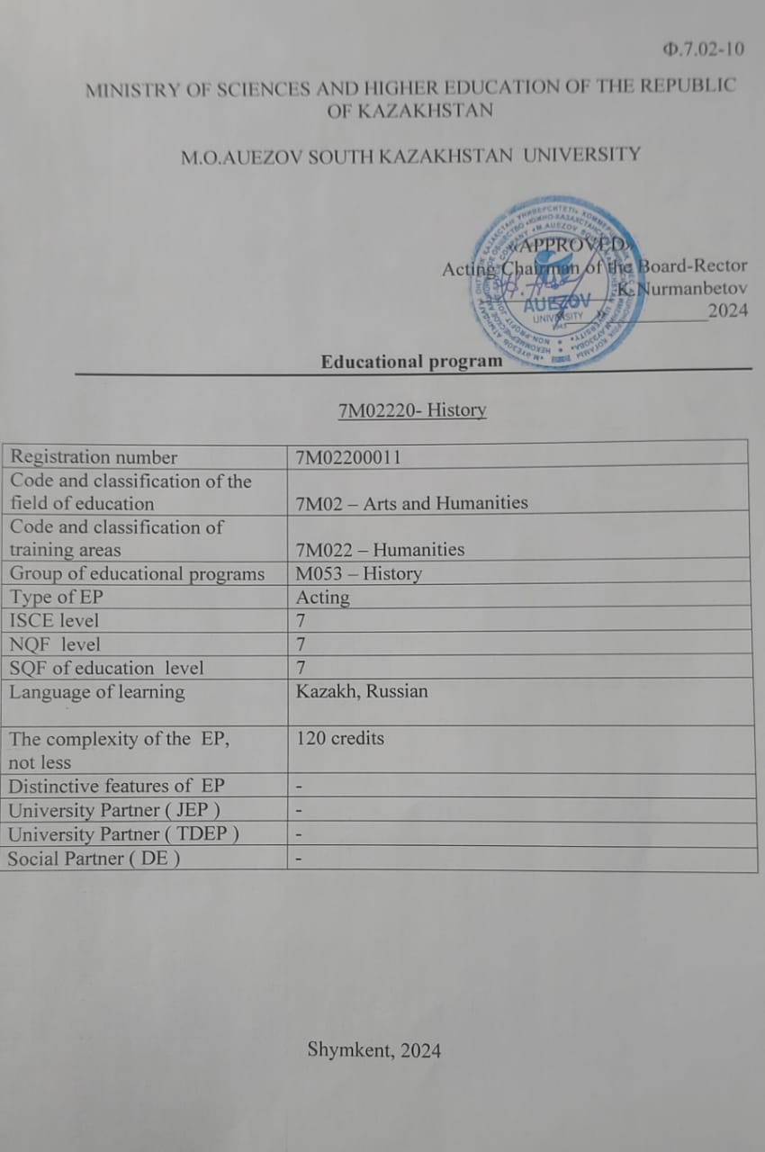

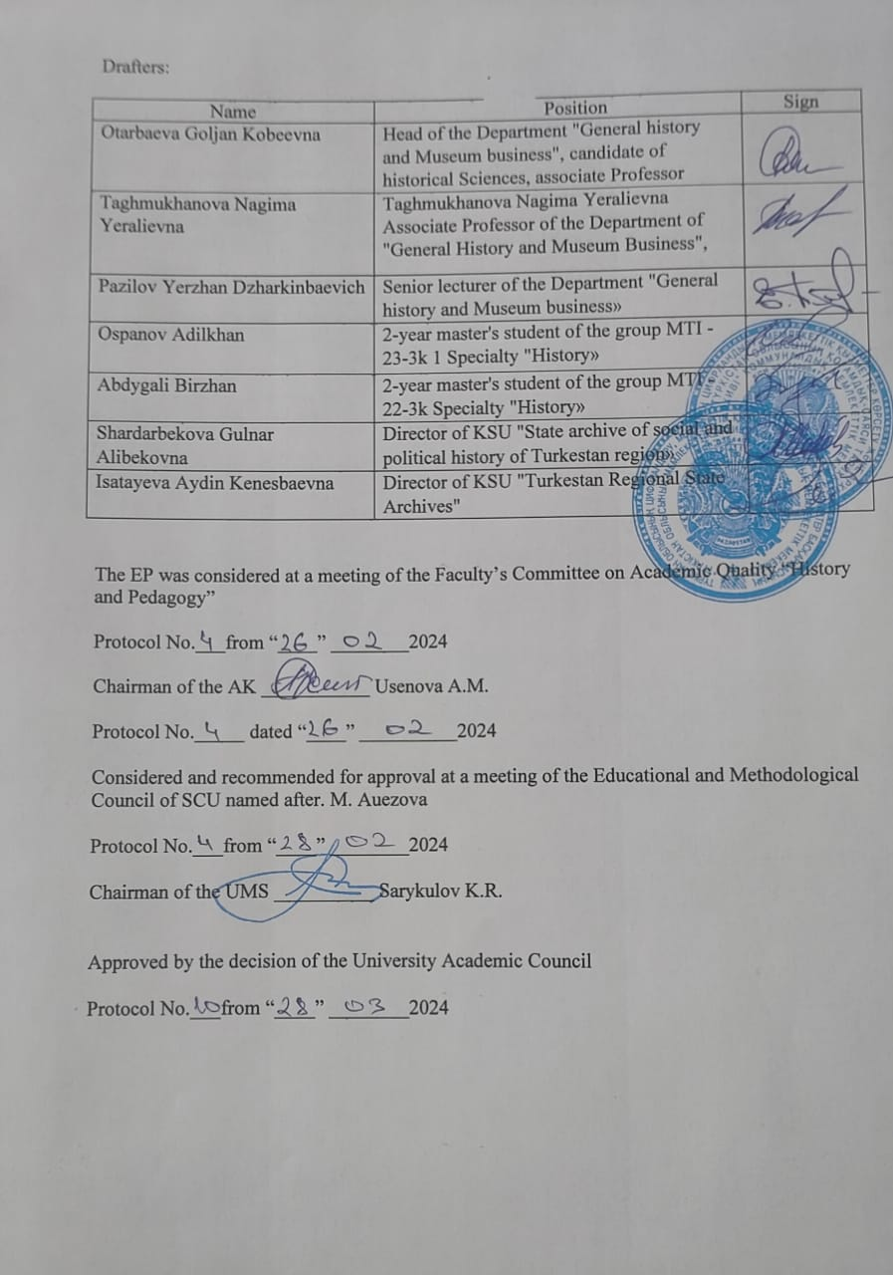

Ф.7.02-10
MINISTRY OF SCIENCEs AND higher EDUCATION OF THE REPUBLIC OF KAZAKHSTAN

M.О.AUEZOV South Kazakhstan University

«APPROVED»
Chairman of the board -
Rector __________________
Doctor of historical sciences,
Academician, Kozhamzharova D.P.
«___»__________2023

Educational program

7М02220- History

Registration number | 7М02200011
Code and classification of the field of education | 7М02 – Arts and Humanities
Code and classification of training areas | 7М022 – Humanities
Group of educational programs | М053 – History
Type of EP | Acting
ISCE level | 7
NQF level | 7
SQF of education level | 7
Language of learning | Kazakh, Russian
The complexity of the EP,  not less | 120 credits
Distinctive features of EP | -
University Partner ( JEP ) | -
University Partner ( TDEP ) | -
Social Partner ( DE ) | -

Shymkent, 2023

Drafters:
Name | Position |  |  | Sign
Otarbaevа Goljan Kоbеevna | Head of the Department "General history and Museum business", candidate of historical Sciences, associate Professor
Taghmukhanova Nagima Yeralievna | Taghmukhanova Nagima Yeralievna Associate Professor of the Department of "General History and Museum Business",
Pazilov Yerzhan Dzharkinbaevich | Senior lecturer of the Department "General history and Museum business»
Kurmangali Zholbolsyn | 2-year master's student of the group MTI -20-3k 1 Specialty "History»
Abdygali Birzhan | 2-year master's student of the group MTI -22-3k Specialty "History»
Shardarbekova Gulnar Alibekovna | Director of KSU "State archive of social and political history of Turkestan region»
Isatayeva Aydin Kenesbaevna | Director of KSU "Turkestan Regional State Archives"

The educational program was reviewed by the Academic Commission for the Humanities,

Protocol № from «___» _________2023 y.

Chairman of the AK ________________
signature-

Rasmussen and recomendovana K uttwerzhdeniю at Sessions School-methodicheskogo Soveta ю their classes

Protocol № from «___» _________2023 y.

Uttwerjdena rescheniem Scientific Council M.Auezov South Kazakhstan State University,

Protocol № from «___» _________2023 y.

The educational program was developed with the participation of the partner university - the Republic of Turkey, Kutahya, Kutahya Dumlupinar University.

CONTENT

1 | Program concept | 4
2 | Passport of the educational program (EP) | 5
3 | Graduate competencies | 7
4 | Matrix of the influence of disciplines on the formation of learning outcomes and information about labor intensity | 10
5 | Summary table reflecting the volume of loans disbursed in the context of OP modules | 20
6 | Learning strategies and methods, monitoring and evaluation | 21
7 | Educational and resource support of the EP | 22

1. CONCEPT OF THE PROGRAM
University Mission | Generation of new competencies, training of a leader who translates research and entrepreneurial thinking and culture
University Values | • Openness–open to change, innovation and cooperation.  • Creativity – generates ideas, develops them and turns them into values.  • Academic freedom – free to choose, develop and act.  • Partnership – creates trust and support in a relationship where everyone wins.  • Social responsibility – ready to fulfill obligations, make decisions and be responsible for their results.
Graduate Model | • Deep subject knowledge, their application and continuous expansion in professional activity.  • Information and digital literacy and mobility in rapidly changing conditions.  • Research skills, creativity and emotional intelligence.  • Entrepreneurship, independence and responsibility for their activities and well-being.  • Global and national citizenship, tolerance to cultures and languages.
The uniqueness of the educational program | • Orientation to the regional labor market and social order through the formation of professional competencies of the graduate, adjusted to the requirements of stakeholders  • Practical orientation and emphasis on the development of critical thinking and entrepreneurship, the formation of a wide range of skills that will allow to be functionally literate and competitive in any life situation and be in demand in the labor market
Academic Integrity and Ethics Policy | The University has taken measures to maintain academic integrity and academic freedom, protection from any kind of intolerance and discrimination:  • Rules of academic integrity (Minutes of the Academic Council No. 3 dated 30.10.2018);  • Anti-Corruption Standard (Order No. 373 n/k dated 27.12.2019).  • Code of Ethics (Protocol of the Academic Council No. 8 dated 31.01.2020).
Regulatory and legal framework for the development of EP | 1. Law of the Republic of Kazakhstan "On Education";  2. Standard rules of activity of educational organizations implementing educational programs of higher and (or) postgraduate education, approved by Order of the Ministry of Education and Science of the Republic of Kazakhstan dated October 30, 2018 No. 595 and with amendments and additions dated December 29, 2021 No. 614;  3. State mandatory standards of higher and postgraduate education, approved by the Order of the Ministry of Science and Higher Education of the Republic of Kazakhstan dated July 20, 2022 No. 2;  4. Rules for organizing the educational process on credit technology of education, approved by order of the Ministry of Education and Science of the Republic of Kazakhstan dated April 20, 2011 No. 152;  5. Qualification directory of positions of managers, specialists and other employees, approved by order of the Minister of Labor and Social Protection of the Population of the Republic of Kazakhstan dated December 30, 2020 No. 553.  6. Guidelines for the use of ECTS.  7. Guidelines for the development of educational programs for higher and postgraduate education, Appendix 1 to the order of the Director of the Center for the Bologna Process and Academic Mobility No. 45 o / d dated June 30, 2021
Organization of the educational process | • Implementation of the principles of the Bologna Process  • Student-centered learning  • Availability  • Inclusivity
Quality assurance of the Educational program | • Internal quality assurance system  • Involvement of stakeholders in the development of the Educational Program and its evaluation  • Systematic monitoring  • Actualization of the content (updating)
Requirements for applicants | It is established according to the Model Rules for admission to training in educational organizations, implementing educational programs of higher and postgraduate education, Order of the Ministry of Education and Science of the Republic of Kazakhstan No. 600 dated 31.10.2018

2. PASSPORT OF THE EDUCATIONAL PROGRAM
Purpose of the EP | Preparation of highly qualified masters with analytical and critical thinking, ready for scientific, pedagogical and research activities in the field of history
Tasks of the EP | - creation of conditions for comprehensive training of masters in accordance with educational standards;  - providing deep theoretical and practical knowledge in the field of historical science;  - development of conceptual, analytical and logical thinking skills;  - formation of a worldview position that meets the requirements of modern society;  -development of the ability to conduct research.
Harmonization of EP | • 7th level of the National Qualifications Framework of the Republic of Kazakhstan;  • Dublin descriptors of the 6th level of qualification;  • 2 cycle of a Framework for Qualification of the European Higher Education Area);  • 7th Level of European Qualification Framework for Life long Learning).
Connection of the EP with the professional sphere | Masters of Humanities have the right to hold positions without presenting work experience requirements in accordance with the Professional Standard "Teacher" - Appendix to the Order of the Chairman Board of the National Chamber of Entrepreneurs of the Republic of Kazakhstan "Atameken" No. 133 dated June 8, 2017
Name of degree awarded | After the successful completion of this EP "7M02220 – History", the graduate is awarded the degree of "Master of Humanities".
List of qualifications and positions | - chief scientific officer,  - general Director,  - director (head) of the organization,  -head) of the department of scientific and technical information,  -a teacher, a teacher in higher educational institutions,  -an employee of archives, museums, libraries,  -expert and analyst, state and municipal employee, creative media worker,  -specialist in historical, cultural and educational tourism
Field of professional activity | -education;  - humanities;  -socio-political and cultural sphere
Objects of professional activity | - research institutions;  - museums, archives;  - higher educational institutions, research and analytical centers, foundations, universities, colleges, gymnasiums, political parties, socio-political organizations and movements, mass media;  - state organizations and institutions entitled to historical and cultural research;  - state governing bodies of science, education and culture.
Subjects of professional activity | - innovative activity in the field of education,  -research work,  - expertise of socio-cultural projects,  -implementation of professional teaching,  socio-political, cultural and educational activities,  - information and analytical centers, public, state institutions and organizations.
Types of professional activity | - educational;  - pedagogical;  - research.
Learning outcomes | LO1- be able to communicate in society and professional environment in a foreign language, read original primary sources, communicate your ideas to the scientific community;  LO2 - apply the conceptual provisions of historical science, philosophy of science and historical cognition in professional activity;  LO3 - master the methods of higher school pedagogy, management psychology for teamwork, productively interacting with team members on the organization of scientific, pedagogical and research activities;  LO4 - critically analyze and interpret scientific research using an interdisciplinary approach in the field of historical science;  LO5 - analyze source and historiographical, archival documents on topical issues of national and world history with the involvement of modern information technologies;  LO6- to comprehensively investigate the patterns of socio-demographic, political development, the main stages of integration processes, the local history of Kazakhstan and the phenomenon of personality in world history;  LO7 - to master modern methodological principles, concepts of everyday life, oral history and adapt them to scientific research;  LO8 - to compare and evaluate the main patterns of political processes in Eurasia, the national and cultural development of the Turkic world and the countries of Central Asia.

3. GRADUATE COMPETENCIES
SOFT SKILLS (Behavioral skills and personality qualities)
SS 1. Competence in managing one's own literacy | SS1.1. Strive for professional and personal growth throughout life.  SS 1.2. Constantly update own knowledge within the chosen trajectory and in an interdisciplinary environment, carry out further learning with a high degree of independence and self-regulation.  SS 1.3. To be capable of reflection, an objective assessment of one's achievements, an awareness of the need to form new competencies and continue education in doctoral studies.
SS 2. Language competence | SS2.1. The ability of possessing a sufficient level of communication in the professional field in the state, Russian and foreign languages for negotiating and business correspondence.  SS 2.2. The ability of mastering the skills of mediation and intercultural understanding.
SS 3. Mathematical Competence and Competence in the field of Science | SS3.1. The ability to interpret the methods of mathematical analysis and modeling for solving applied problems in the field of study.  SS3.2. The ability to plan the setting of scientific experiments, integrate and implement the results of scientific research in the professional field.  SS 3.3. The ability to analyze and comprehend modern methods of pedagogical and psychological science and apply them in pedagogical activity.
SS 4. Digital competence, technological literacy | SS 4.1. The ability to confidently use modern information and digital technologies, artificial intelligence systems for work, leisure and communications.  SS 4.2. Proficiency in the use, recovery, evaluation, storage, production, presentation and exchange of information in a wide range of digital devices.  SS 4.3. Ability to confidently use global information resources and apply technological literacy in research and computational and analytical activities.
SS 5. Personal, social and academic competencies | SS 5.1. Possession of the norms of business ethics, social and ethical values and focus on them in professional activities.  SS 5.2. Formation of a personality capable of mobility in the modern world, critical thinking and physical self-improvement.  SS 5.3. Ability to work in a team, correctly, clearly and reasonably defend one's position during discussions and make decisions of a professional nature.  SS 5.4. Ability to adequately navigate in various social spheres of activity and in conditions of uncertainty.  SS 5.5. Ability to find compromises, correlate own opinion with the opinion of the team.
SS 6. Entrepreneurial competence | SS 6.1. The manifestation of leadership qualities and the ability to have a positive impact on others, to lead a team.  SS 6.2. The ability to create conditions for the development of creative and entrepreneurial skills of the team.  SS 6.3. The ability to work in a mode of uncertainty and rapidly changing task conditions, make decisions, respond to changing working conditions, allocate resources and manage your time.  SS 6.4. Ability to work with consumer needs.
SS 7. Cultural awareness and ability to express yourself | SS7.1. The ability to show worldview, civil and moral positions.  SS7.2. The ability to be tolerant of the traditions and culture of the peoples of the world, to have high spiritual qualities.
PROFESSIONAL COMPETENCIES (HARDSKILLS).
Theoretical knowledge and practical skills specific to this field | PC1. Capable of preparing and conducting research works in accordance with the profile of the master's program using knowledge of fundamental and applied disciplines of the master's program
 | PC 2. Possess the skills of planning and implementing pedagogical activities in higher education
 | PC 3. Is able to use knowledge in the field of humanities in the implementation of research, analytical, expert activities
 | PC 4. Possess the skills of independent processing of the studied materials, their analysis and interpretation
 | PC 5. Willingness to use acquired knowledge in organizational and managerial work in the field of education, science and culture
 | PC 6. Capable of carrying out historical-cultural and historical-local history functions in the activities of organizations and institutions (NPTs, laboratories, museums, etc.)
 | PC 7. Capable of preparing analytical information (taking into account ethno-political, ethno-social, ethno- and socio-cultural specifics) for decision-making by public administration and local self-government bodies

3.1 Matrix of correlation of learning outcomes on the EP as a whole with the competencies being formed

 | LО-1 | LО-2 | LО-3 | LО-4 | LО-5 | LО-6 | LО-7 | LО-8
SS 1 | + | + | + |  | + |  | + | +
SS 2 | + |  | + | + |  | +
SS 3 | + |  |  | + |  | + |  | +
SS 4 | + |  | + | + |  | + | +
SS 5 |  | + | + |  | + |  | + | +
SS 6 |  | + | + | + | + |  | + | +
SS 7 | + |  |  | + | +
РС 1 | + | + |  |  |  |  |  | +
РС 2 |  |  | + | + | + | +
РС 3 |  | + |  | + | + | + | +
РС 4 |  |  |  | + | + | + | + | +
РС 5 | + | + | + |  |  |  | +
РС 6 |  |  | + | + | + | +
РС 7 |  | + | + | + | + |  | + | +

4. MATRIX OF THE INFLUENCE OF DISCIPLINES ON THE FORMATION OF LEARNING OUTCOMES AND INFORMATION ABOUT LABOR INTENSITY
№ | Module name | Cycle | Component | Name of the discipline | Brief description of the discipline | Number of credits | Formed РО (codes)
 |  |  |  |  |  |  | РО1 | РО2 | РО3 | РО4 | РО5 | РО6 | РО7 | РО8
1 | Module of scientific and pedagogical training | BD | UC | The History and Philosophy of Science | Purpose: to form the skills of applying the conceptual provisions of the philosophy of science and historical knowledge in professional activity.  Content: systematizes knowledge about the history and philosophy of the humanities. Summarizes information about the New European science in culture and civilization, the emergence of science, its historical dynamics, the structure of scientific knowledge. Characterizes essence of communication technologies of the XXI century and their role in modern science. | 4 |  | ✓
1 | Module of scientific and pedagogical training | BD | UC | Foreign language (professional) | Purpose: to form the ability to perceive the general content of authentic recordings and to listen to lectures containing professional information.  Content: explores the main types of reading foreign-language original sources with varying degrees of content coverage. Produces written reports on scientific topics in the specialty: abstracts on the topic of scientific research, carries out the abstraction of original primary sources in a foreign language, annotation of scientific text, summary. | 4 | ✓
 | Module of scientific and pedagogical training | BD | UC | Psychology of management | Purpose: to form the skills of management psychology in teamwork in the organization of scientific, pedagogical and research activities.  Content: The main approaches and principles of modern psychological science necessary for highly qualified specialists in professional activity are characterized. They are aimed at activating the psychological potential of the individual and the team for the successful solution of managerial tasks. | 4 |  |  | ✓
2 | Methodical bases of teaching | BD | UC | Pedagogy of higher education | Purpose: to develop critical thinking, analyzes the basic principles, methods and methodology of pedagogical science.  Content: The essence of the basic concepts of the science of education, the relationship of pedagogy with other sciences, the issues of the global education crisis, modern megatrends of education development, theories are revealed education and upbringing, credit system of education, management of universities, theory of scientific activity of higher education, history. | 4 |  |  | ✓
2 | Methodical bases of teaching | BD | UC | Teaching methods of special disciplines | Purpose: formation of modern complex methodological, research, artistic and creative thinking of teaching humanities in higher education among future specialists.  Content: The theoretical foundations of teaching humanities at the university are studied. Reveals the features of teaching specialized disciplines related to the content and structure of curricula, educational and methodological complexes. Characterizes the principles of their construction. Methods of conducting practical classes of special disciplines: seminar, laboratory, workshop. | 5 |  |  | ✓
 | Methodical bases of teaching | BD | UC | Pedagogical practice | Purpose: formation of practical skills of teaching and learning methods.  Content: Develops critical thinking, the ability to conduct training sessions using modern educational information technologies. Strengthens the knowledge, skills and abilities acquired in the educational, pedagogical and research processes, introduces the methodology of preparation and conduct of various forms of classes. The independent development of working curricula, thematic planning of scheduled and extracurricular activities. | 4
3 | Information technologies in historical science | BD | EC | National and Cultural Development Strategies of the Central Asian Countries | To conduct a comparative analysis of the current state of national and cultural processes in the countries of Central Asia.  Content: the features of the development of the Central Asian countries and the ways of forming national and cultural strategies of traditional and modernizing society are studied. Recommendations for the Central Asian States on improving the implementation of national digitalization and ICT strategies in the post-pandemic world. | 6 |  |  |  |  |  |  |  | ✓
3 | Information technologies in historical science |  |  | Problems of Studying the History of the Turkic Peoples at the Present Stage | The regularities and main stages of the integration political processes of the Turkic world are comprehensively investigated.  Content: The discipline is aimed at studying the history of the Turkic peoples at the present stage with the involvement of primary sources and scientific works on the history of the Turkic peoples. The historical, ethnogenetic, ethno-cultural relations of the Turkic peoples at the present stage are investigated. | 6 |  |  |  |  |  |  |  | ✓
3 | Information technologies in historical science | BD | EC | Information technologies in historical science and history teaching | Purpose: to form the ability to plan and organize at different levels the use of modern information technologies, search, analysis and evaluation of network resources on topical issues of national and world history.  Content: Informatization of the educational process in historical science and history teaching. The skills and abilities of applying the methodology of history using geoinformation systems are being formed. | 4 |  |  |  |  | ✓
3 | Information technologies in historical science | BD | EC | Geographic information systems in historical and demographic research | Purpose: to form the ability to use geoinformation technologies in historical and demographic research.  Content: GIS technologies in historical and demographic research based on the analysis of sources, parameterization and increasing the nomenclature of types of models. Visual design of models of the course of historical and demographic spatial processes (scenarios of the course) for the implementation of simulation modeling with the involvement of modern information technologies. | 4 |  |  |  |  | ✓
 |  |  |  | Research practice | Familiarization with the latest theoretical, methodological and technological achievements of domestic and foreign science, modern methods of scientific research, processing and interpretation of experimental data. | 6
4 | Modern theoretical and methodological problems of history | BD | EC | Methods and methodology of historical science: domestic and foreign experience | Purpose: formation of students' competence system in the field of theoretical and methodological foundations of historical science, acquaintance with the ideas of leading schools of historical thought, with the content of principles, categories and methods of historical cognition.  Content: Methods and techniques of modern historical research. The Annals School and Historical Anthropology. The formation of the history of mentalities. F. Aries, R. Mandru, J. le Goff, Le Roy Laduri. Gender studies in historical sciences. | 6 |  |  |  |  | ✓ | ✓
4 | Modern theoretical and methodological problems of history | BD | EC | Theoretical and methodological problems of the recent history of Central Asia | Purpose: to form scientific ideas about the main directions of research and methodology of the modern history of Central Asia.  Content: The subject, functions and significance of the recent history Central Asia. Principles and methods of studying the modern history of Central Asia. Socio-political and economic crisis in the USSR. Confessional politics and interfaith relations in Central Asia. Relations of Central Asia with Russia, China, the USA and the EU. | 6 |  |  |  |  | ✓ | ✓
4 | Modern theoretical and methodological problems of history | BD | EC | Oral history: methods and direction of historical research | To develop logical thinking, the ability to develop a concept, formulate goals and objectives of research in the collection and interpretation of oral materials using modern information technologies.  Contents: Methodological foundations of oral history. Formation and development of oral history in Western Europe and the USA. Oral history and Russian historical science. The methodology of conducting a historical interview. Methods of audio and video recording and archiving of information. Organization of access and work with oral history materials. Publication of interview materials. | 5 |  |  |  |  |  |  | ✓
4 | Modern theoretical and methodological problems of history | BD | EC | History of everyday life: methodology and research methods | Purpose: to give an idea of the typological features of the culture of everyday life as an integral phenomenon.  Content: The subject of everyday culture. The concept of everyday life. Sources on the history of everyday life. Everyday life in the most ancient cultural and historical centers of the East. Food innovations of the XVII century. The nineteenth century: the new space of everyday life and other civilizations. The lifestyle of different classes.
4 | Modern theoretical and methodological problems of history | BD | EC | Interdisciplinary approaches in historical science | Purpose: to familiarize undergraduates with the phenomenon of interdisciplinarity in modern socio-humanitarian research, with the possibilities of using methods of "related" social and humanitarian disciplines in historical research.  Content: Methodological basis of interdisciplinary research. Common and different in social and humanitarian disciplines. The history of the development of interdisciplinary interaction of humanities and social disciplines. Methods of social anthropology in historical research. Semiotic methods in historical research. | 5 |  |  |  | ✓
4 | Modern theoretical and methodological problems of history | BD | EC | Synergetic approach in historical and historiographical research | To track the developments of positive trends and problems in the development of a synergetic worldview, in applying it as a methodological basis for historical research.  Content: Aspects of the application of the synergetic approach in historical and historiographical research. Synergetics in an interdisciplinary dimension. Synergetics as a means of integrating natural science and humanities education.
 |  | PD | EC | The phenomenon of personality in the history of Kazakhstan | Purpose: to form the skills of comparative analysis and evaluation of the phenomenon of personality in the history of Kazakhstan.  Content: The role and place of the historical personality in history, special functions in the system of social reality. Analyzes the internal state of society in various formats. Great personalities in the history of Kazakhstan: Al-Farabi, A. Iassawi, A. Kunanbayev, A. Bokeikhanov. | 5 |  |  |  |  | ✓
 |  | PD | EC | Directions of demographic policy of the Republic of Kazakhstan | Purpose: applies skills and abilities, the main methods and methods of conducting demographic research, methods of determining the population of the Republic of Kazakhstan.  Content: Examines the main problems and tasks of studying historical demography. Examines the dynamics of population growth, the theory of the migration process, analyzes the political development of the country and the socio-demographic situation. The concept of the state demographic policy of the Republic of Kazakhstan.
 |  |  |  | Totalitarian System in USSR and its Сonsequences in Kazakhstan (1920-1950 years) | To form complex ideas about the essence of "totalitarianism in the USSR" and its consequences in Kazakhstan. Examines the theoretical and practical aspects of the evolution of the Soviet political regime, which historically existed in the form of authoritarian, totalitarian and democratic regimes with their own characteristics. The formation of the totalitarian regime in the USSR. Kazakh society of 1920-1950 in the conditions of totalitarianism. | 5 |  |  |  | ✓
 |  |  |  | Kazakhstan in the Soviet Empire: politics, Economics, Social Relations | To form knowledge about the most important events and patterns of the historical development of Kazakhstan as part of the Soviet Union. Contents: Kazakhstan at the initial stage of Bolshevik reform and power Bolshevik modernization, the creation of autonomy "Alash", the formation of the KASSR, mass famine of the early 30s, deportation of peoples, political repression in Kazakhstan.
5 | Organization and planning of historical research | PD | EC | Organization and planning of scientific research | Purpose: to develop the ability to plan, organize and carry out scientific research, the skills of registration, protection, implementation of the results of scientific research and intellectual property rights (patenting).  Content: knowledge is being formed about the fundamentals of international and national law in the field of scientific research, the main types of financing of science in the country, the mechanism for obtaining funds for science, the principles of scientific project management, the main forms of scientific publications of research results. | 4 |  |  |  | ✓
5 | Organization and planning of historical research | PD | EC | Historical textology | Purpose: to familiarize undergraduates with the basic principles, concepts, techniques and methods of textual research.  Content: Object, subject, purpose, tasks and methods of historical textual analysis. Genetic dossier and methods of its formation. Textual structuring of historical source retrospective information. The place of textual analysis in the general characteristics of the historical source. The use of the results of textual analysis in historical reconstruction.
5 | Organization and planning of historical research | PD | EC | The Political Processes of Eurasia of the twentieth century: historical aspect | Purpose: to form scientific ideas about methodological approaches to the study of political processes in Eurasia, controversial moments in the study of the history of the Stalinist period.  Contents: The main patterns of the development of political processes in Eurasia in the twentieth century in the historical aspect are investigated. The external dimension of the political history of Eurasia. The collapse of colonial empires and the emergence of new states. | 5 |  |  |  |  |  |  |  | ✓
5 | Organization and planning of historical research | PD | EC | Kazakhstan in the system of international relations | Purpose: to familiarize undergraduates with the main problems of international relations in the world, the role and place of Kazakhstan's foreign policy.  Contents: World politics and modern international relations of the Republic of Kazakhstan in the system of international relations. Kazakhstan's activities in the UN. Cooperation of Kazakhstan with the Central Asian States. Kazakh-Chinese relations. Kazakhstan and the EU countries. | 5 |  |  |  |  |  |  |  | ✓
5 | Organization and planning of historical research | PD | EC | Scientific foundations of archival science and documentation | Purpose: to develop skills of working with historical information arrays, their expert assessment to develop their own position in accordance with the profile of scientific research.  Content: The concept of a document. Document system. Documentary activity. General principles of systematization and classification of documents. Modern classifications of documents. Documentation systems. Document resources. The subject and basic concepts of archival science. The history and practice of archival work in Kazakhstan. | 6 |  |  |  |  | ✓
5 | Organization and planning of historical research | PD | EC | Theoretical and methodological problems of source studies and historiography | Purpose: to familiarize undergraduates with the theoretical and methodological problems of source studies and historiography, to formulate professional skills of source and historiographical analysis and synthesis.  Contents: Theoretical and methodological problems of historical research. Methodology and methods of scientific research. Method as the main tool of cognition. The method of source studies and special techniques in the study of the origin and content of historical sources.
5 | Organization and planning of historical research | PD | EC | Applied Sociology in Historical Research: Methodology and Method | Purpose: to teach critically analyze and interpret scientific research using concepts and methods of sociology in historical and anthropological research.  Contents: Fundamentals of methodology in sociology. Directions of application of sociological methods in historical research. The program of sociological research. The survey as a method of sociological research. The quality of sociological information. Types of errors, causes of errors, measures to prevent them. Random and systematic errors. | 6 |  |  |  | ✓
5 | Organization and planning of historical research | PD | EC | New local history Kazakhstan: Problems of education | To form the competence of comparative research on the key positions of classical forms of local history research, including the local history tradition, and research practices of new local history.  Contents: New local history of Kazakhstan: origin, concepts, place in modern historiography. Research principles and methodological tools  of the "new local history". The concept of a multiethnic macroregion and the main directions in the study of the history of Kazakhstan. The history of Kazakhstan in the context of the "new local history".
6 | Research work of a master's student |  |  | Research work of a master's student | Purpose: consolidation of theoretical knowledge gained in the course of training, acquisition of practical skills, competencies and professional experience.  Content: To form the ability and skills of conducting scientific research, using modern principles and methods of research, drawing up a work plan, searching and collecting scientific materials, analyzing and interpreting data on the topic of the dissertation. | 24
6 | Research work of a master's student |  |  | Preparation and defense of a master's thesis | It is planned to check (final control) the knowledge of a fundamental theoretical and applied nature obtained by the graduate during the entire period of study, as well as the formed skills and abilities that indicate his professional readiness. | 8 |  |  |  |  | ✓

4.1 Summary table showing the volume of loans disbursed in the context of the modules of the educational program

Course of study | Semester | The number of mastered modules | Number of disciplines |  | Number of KZ credits |  |  |  | Totalhours | Totalloans KZ | Number
Course of study | Semester | The number of mastered modules | ВК | КВ | Theoretical training | Educational practice | Industrial practice | Final examination | Totalhours | Totalloans KZ | exam | deeth.  credit
1 | 1 | 2 | 5 | 1 | 29 | - | 1 | - | 900 | 30 | 6 | -
1 | 2 | 2 | - | 3 | 23 | 4 | 3 | - | 900 | 30 | 4 | -
2 | 3 | 2 | - | 3 | 28 | - | 2 | - | 900 | 30 | 4 | -
2 | 4 | 1 | - | - | - | - | 18 | 12 | 900 | 30 | - | -
total |  |  | 5 | 7 | 80 | 4 | 24 | 12 | 3600 | 240 | 14 | -

6. LEARNING STRATEGIES AND METHODS, MONITORING AND EVALUATION
Learning strategies | Undergraduate–centered learning: the student is the center of teaching/learning and an active participant in the learning and decision-making process.  Practice-oriented training: orientation to the development of practical skills.
Teaching methods | Conducting lectures, seminars, various types of practices:  • using innovative technologies:  • problem-based learning;  • case study;  • work in a group and creative groups;  • discussions and dialogues, intellectual games, olympiads, quizzes;  • reflection methods, projects, benchmarking;  • Bloom's taxonomies;  • presentations;  • rational and creative use of information sources:  • multimedia training programs;  • electronic textbooks;  • digital resources.  Organization of independent work of students, individual consultations.
Monitoring and evaluation of the achievability of learning outcomes | Current control on each topic of the discipline, control of knowledge in classroom and extracurricular classes (according to syllabus). Assessment forms:  • survey in the classroom;  • testing on the topics of the discipline;  • control works;  • protection of independent work;  • discussions;  • trainings;  • colloquiums;  • essays, etc.  Boundary control at least twice during one academic period within the framework of one academic discipline.  Intermediate certification is carried out in accordance with the working curriculum, academic calendar.  Forms of conducting:  • exam in the form of testing;  • oral examination;  • written exam;  • combined exam;  • project protection;  • protection of practice reports.  Final state certification.

EDUCATIONAL AND RESOURCE SUPPORT OF THE EP
Educational Information Center | The structure of the Educational Information Center includes 6 subscriptions, 16 reading rooms, 2 electronic resource centers (ERC). The basis of the network infrastructure of the Educational and Information Center is 180 computers with Internet access, 110 workstations, 6 interactive whiteboards, 2 video doubles, 1 video conferencing system, 3 A-4 format scanners, JIC software - AIBS "IRBIS-64" under MS Windows (basic set of 6 modules), stand-alone server for uninterrupted operation in the IRBIS system.  The library fund is reflected in the electronic catalog available to users on the site http://lib.ukgu.kz on-line 24 hours 7 days a week.  Thematic databases of their own generation: "Almamater", "Proceedings of SKSU scientists", "Electronic archive" have been created. Online access from any device 24/7 via the external link http://articles.ukgu.kz/ru/pps.  Catalogs are processed electronically. EC consists of 9 databases: "Books", "Articles", "Periodicals", "Proceedings of the teaching staff of SKSU", "Rare Books", "Electronic Fund", "SKGU in Print", "Readers" and "SKU".  The EIC provides its users with 3 options for accessing its own electronic information resources: from the “Electronic Catalog” terminals in the catalog hall and in the EIC subdivisions; through the information network of the university for faculties and departments; remotely on the library website http://lib.ukgu.kz/.  Open access to international and republican resources: "SpringerLink", "Polpred", "Web of Science", "EBSCO", "Epigraph", to electronic versions of scientific journals in the public domain, "Zan", "RMEB", "Adebiet", Digital library "Aknurpress", "Smart-kіtаr", "Kitаr.кz", etc.  For people with special needs and disabilities, the library website has been adapted to the work of visually impaired users

Material and technical base | The department has the following classrooms with a total area of 274 m2:  The office of the head of the department is 331 (building No. 7, Baitursynov str.).  Teachers' office-306 (building No. 7, Baitursynova str.).  Computer class-332,333 (building No. 7, Baitursynova str.).  Classrooms-308,310,323 (building No. 7, Baitursynova str.).  Office of undergraduates and doctoral students-331 (building No. 7, Baitursynova str.)  The department is equipped with the following equipment: computers (Core 2 Quad, Intel Core 2 Duo), printer, scanner, local system, etc. There are 33 computers in two computer classes of the department, 3-in-1 MFPs (copier, printer, scanner). In the computer room (302, 309), computers are connected to a network system.

AGREEMENT SHEET

by Education Program 7М02220 - History

Director IPE ______________ Elibaeva G.I.

Director ASD ______________ Nazarbek U.B.

Director DNPiK _____________Bazhirov T.S.

