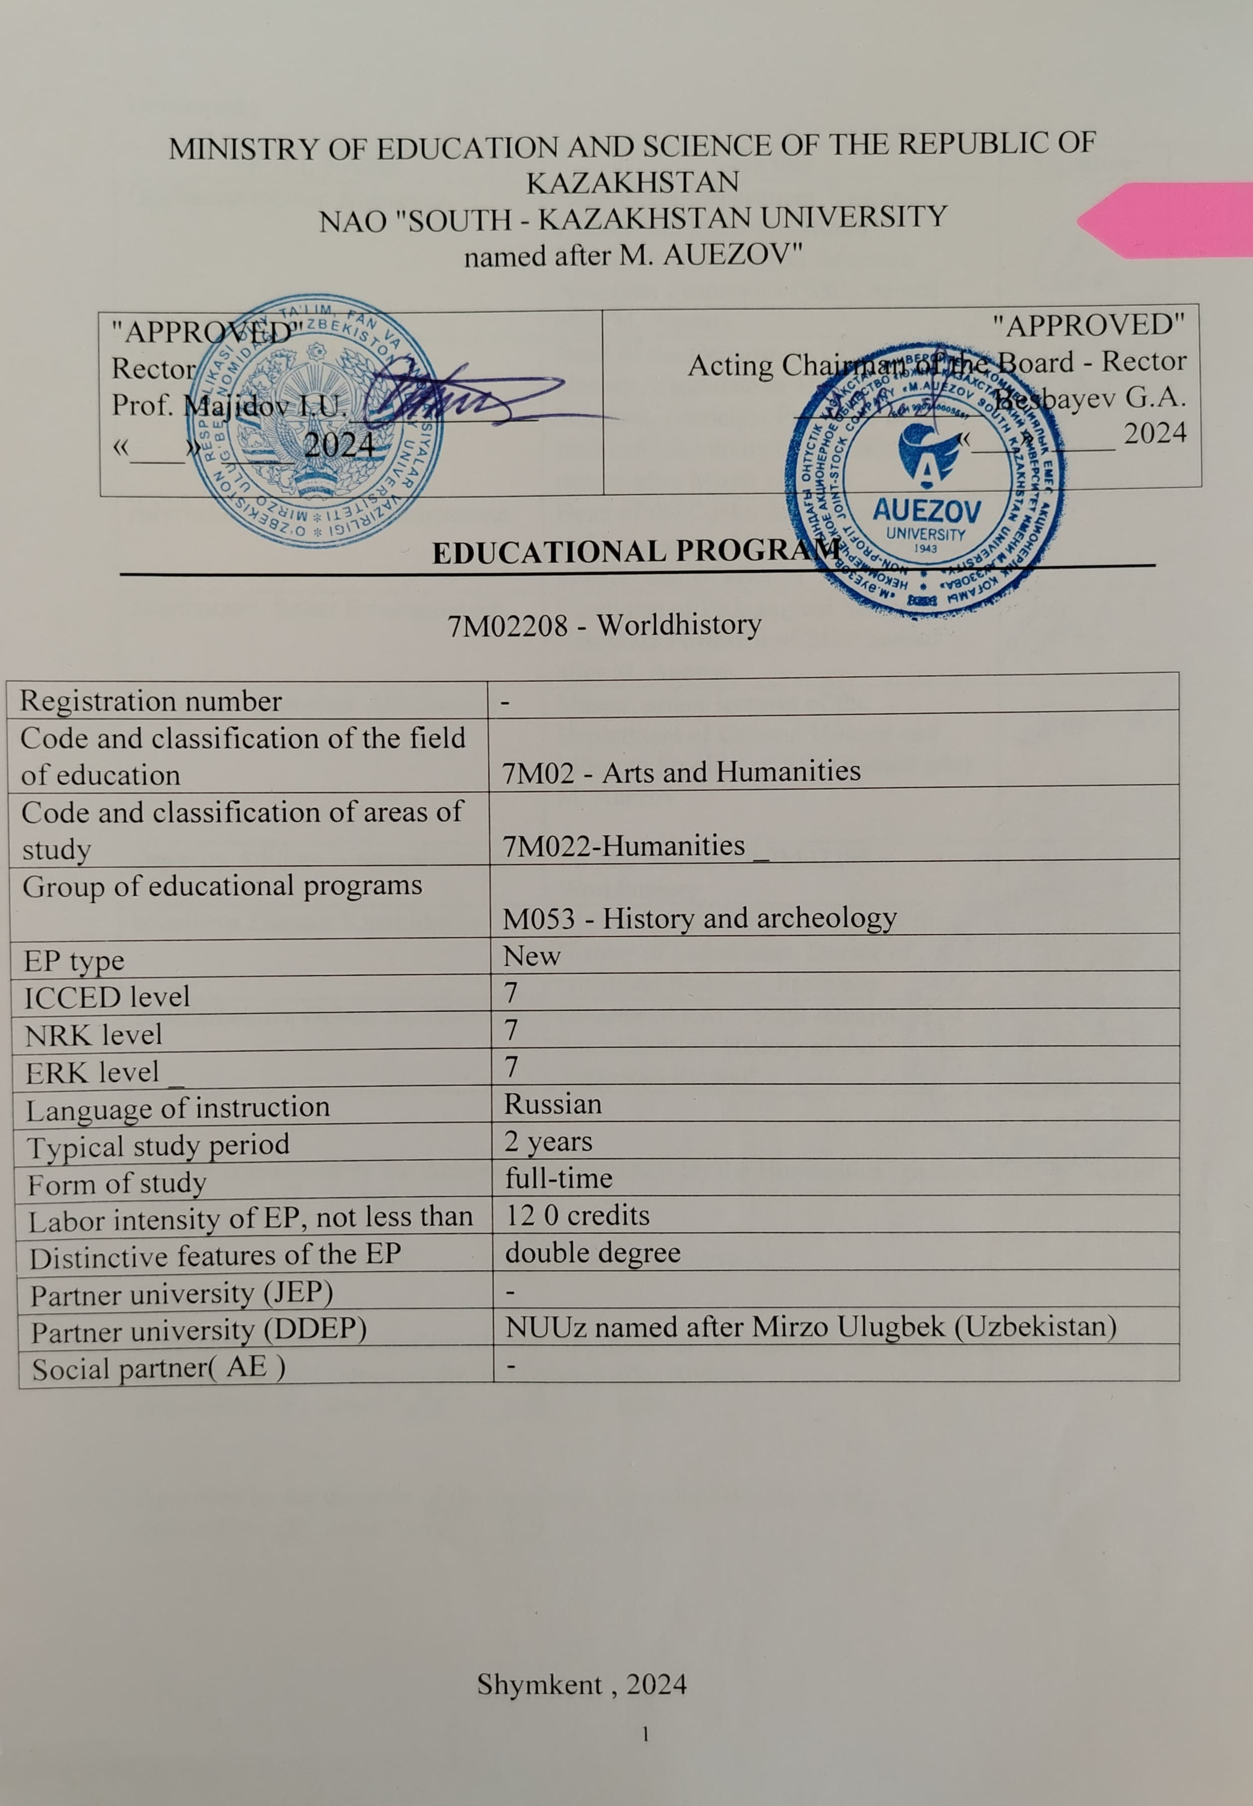

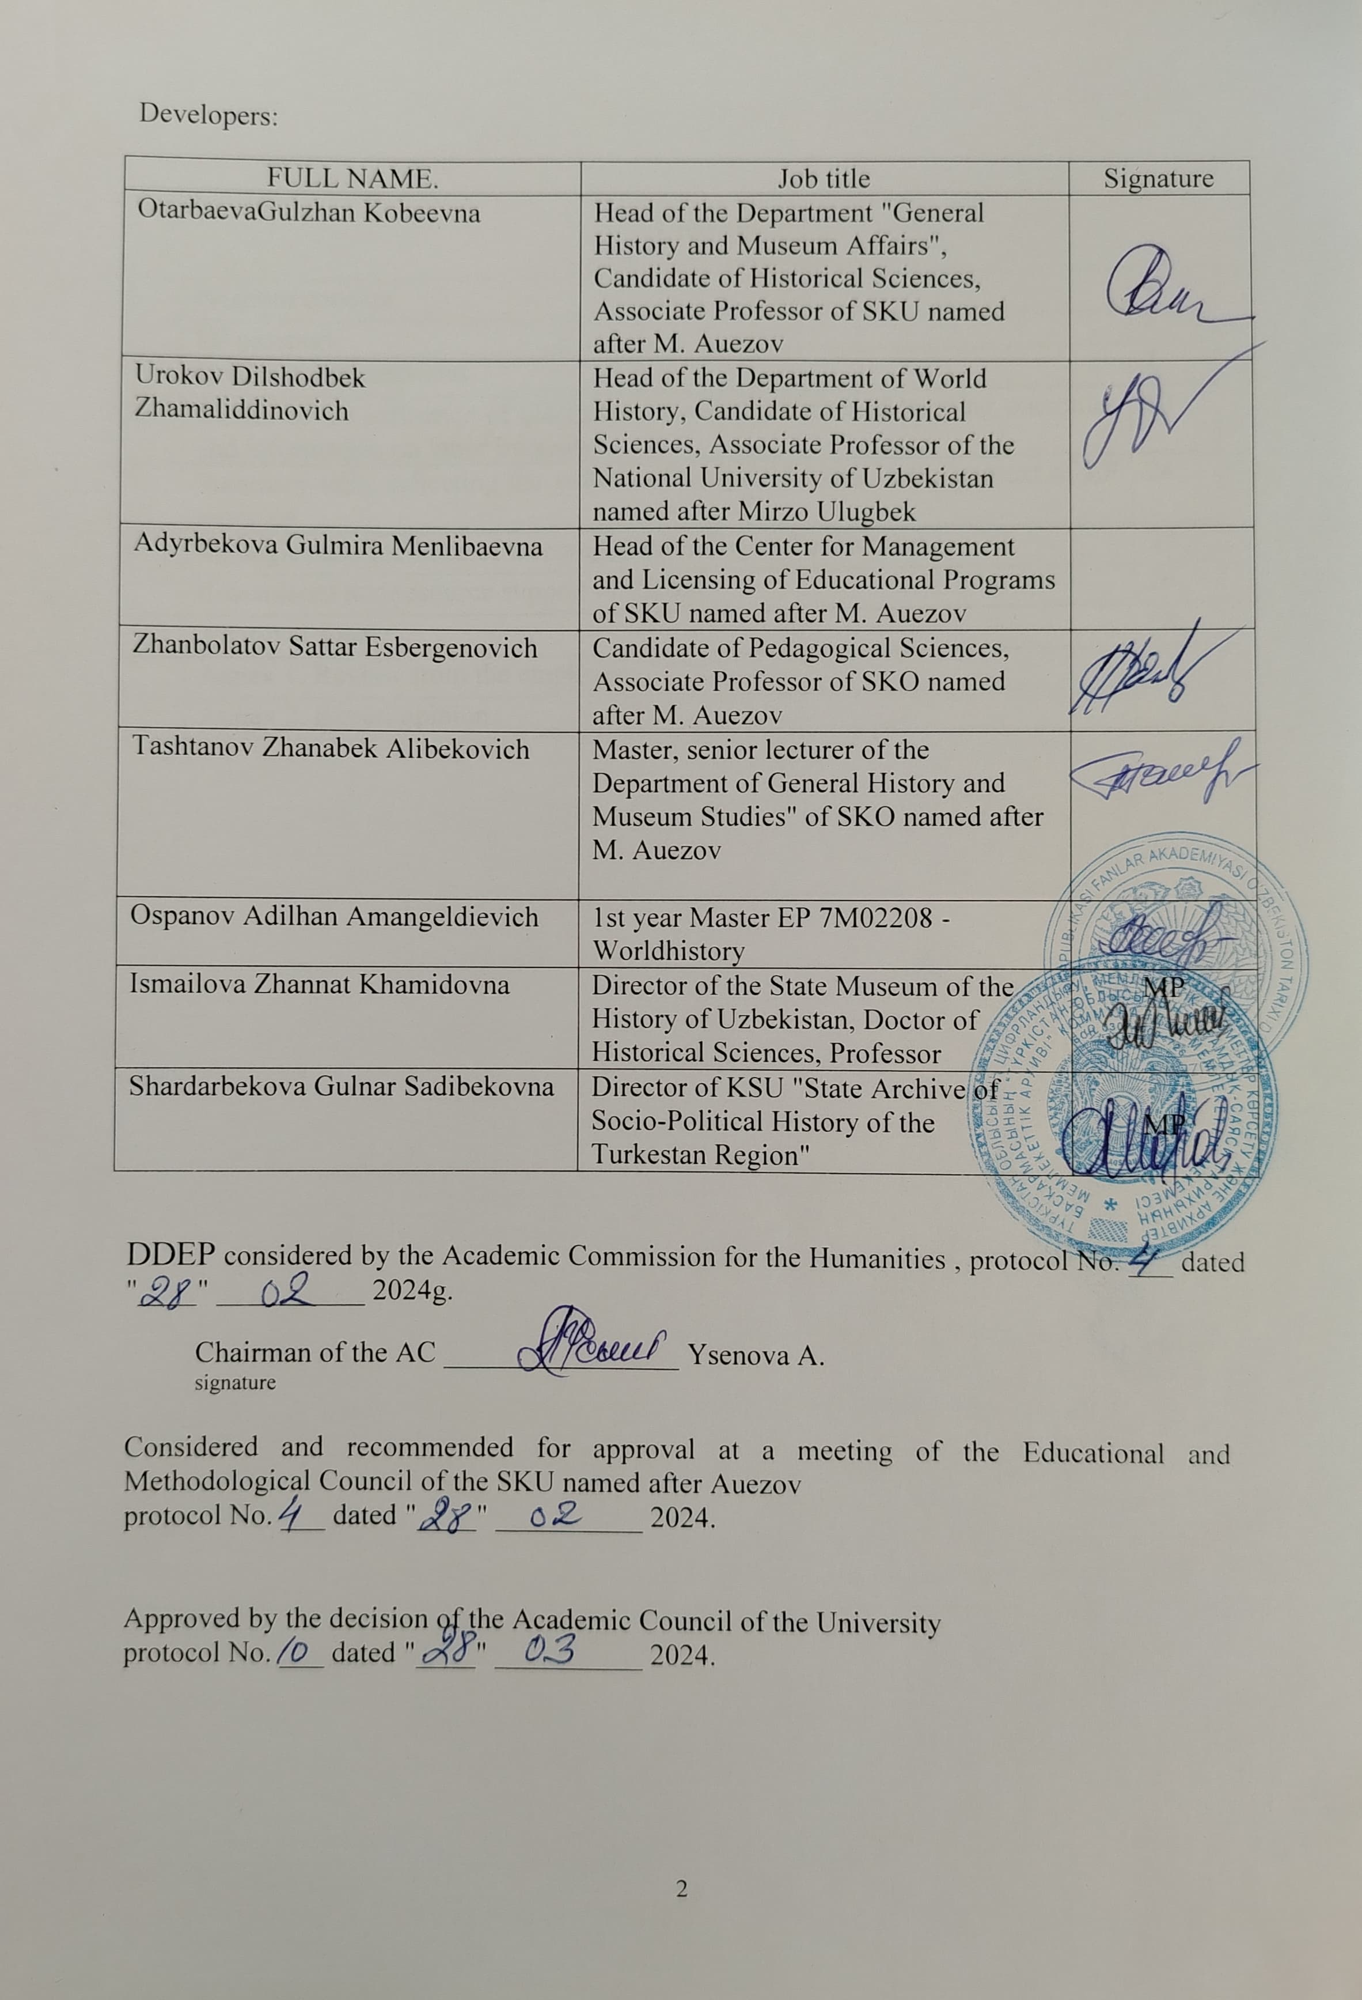

Contents _

|  |  |  |
| --- | --- | --- |
| 1 | Program concept | 4 |
| 2 | EP passport | 5 |
| 3 | Graduate competencies | 7 |
| 4 | Matrix of the influence of disciplines on the formation of learning outcomes and information on labor intensity | 10 |
| 5 | Summary table reflecting the volume of disbursed loans in the context of EP modules | 24 |
| 6 | Strategies and methods of teaching, monitoring and evaluation | 25 |
|  | Educational and resource support of the EP | 26 |
|  | Approval sheet | 28 |
|  | Annex 1. Review from the employer |  |
|  | Annex 2. Expert opinion |  |

**1. CONCEPT OF THE PROGRAM**

|  |  |
| --- | --- |
| **University Mission** | Generation of new competencies, preparation of a leader who translates research and entrepreneurial thinking and culture |
| **University values** | * Openness - open to change , innovation and cooperation .  Creativity - generates ideas, develops them and turns them into values.  * Academic freedom - **free in choice, development and action.** * Partnership - creates trust and support in relationships where everyone wins. * Social responsibility - ready to fulfill obligations, make decisions and be responsible for their results. |
| **Graduate Model** | * Deep subject knowledge, its application and constant expansion in professional activities. * Information and digital literacy and mobility in a rapidly changing environment. * Research skills, creativity and emotional intelligence. * Entrepreneurship, independence and responsibility for their activities and well-being. * Global and national citizenship, tolerance for cultures and languages. |
| **Uniqueness of DD EP** | **The uniqueness of the double-degree educational program** lies in the solution of the tasks of state policy related to the study of the history and culture of Kazakhstan and Uzbekistan , the use of international experience, the prospects for employment of graduates after graduation, the development of progressive knowledge from leading teachers of partner universities, obtaining 2 master 's degrees Humanities in DDEP 7M02208 "World History" (SKU named after M. Auezov) and "History (by directions and types of activity) " (NUUz named after Mirzo Ulugbeka) |
| **Academic Integrity and Ethics Policy** | The university has taken measures to maintain academic honesty and academic freedom, protection from any kind of intolerance and discrimination:   * Rules academic honesty (protocol scientist Council No. 3 dated 10/30/2018 Mr. _ ); * Anti-corruption standard (Order No. 373 n / a of December 27, 2019). * Code ethics (protocol scientist Council No. 8 of 01/31/2020G). |
| **Regulatory and legal framework for the development of DDEP** | 1. Law of the Republic of Kazakhstan "On Education"; 2. Model rules for the activities of educational organizations implementing educational programs of higher and (or) postgraduate education, approved by order of the Ministry of Education and Science of the Republic of Kazakhstan dated October 30, 2018 No. 595; 3. State obligatory standards of higher and postgraduate education, approved by order of the Ministry of Education and Science of the Republic of Kazakhstan dated October 31, 2018 No. 604; 4. Rules for organizing the educational process on credit technology of education, approved by order of the Ministry of Education and Science of the Republic of Kazakhstan dated April 20, 2011 No. 152; 5. Qualification directory of positions of managers, specialists and other employees, approved by order of the Minister of Labor and Social Protection of the Population of the Republic of Kazakhstan dated December 30, 2020 No. 553. 6. Guidelines for the use of ECTS . 7. Guidelines for the development of educational programs for higher and postgraduate education , appendix 1 to the order of the director of the CBPiAM No. 45 o / d dated June 30, 2021 |
| **About the organization of educational _ process** | * Implementation principles Bologna process * Student -centered education * Availability _ * And inclusiveness _ |
| **Quality assurance DD EP** | * In the interior system ensure quality * Attraction stakeholders to the development of the EP and its evaluation * With systematic monitoring * And actualization content (update) |
| **Entry Requirements** | Requirements are established in accordance with the Model Rules for Admission to Education in Educational Organizations Implementing Educational Programs of Higher and Postgraduate Education Order of the Ministry of Education and Science of the Republic of Kazakhstan No. 600 dated 10/31/2018 |
| **Conditions for the implementation of educational programs (EP) for persons with disabilities and special educational needs(SSN)** | For students with SEN (special educational needs) and persons with disabilities (PSI), tactile PVC tiles, specially equipped toilets, a mnemonic diagram, and shower bars have been installed in educational buildings and dormitories. Special parking spaces have been created. Crawler lift installed. There are desks for people with limited mobility (PLM), signs indicating the direction of movement, ramps. In the educational buildings (main building, building No. 8) there are 2 rooms with six working places adapted for users with disorders of the musculoskeletal system (DMS).For visually impaired users, the SARA™ CE Machine (2 pcs.) is available for scanning and reading books. The library website is adapted for the visually impaired. There is a special NVDA audio program with a service. The JIC website http://lib.ukgu.kz/ is open 24/7.  An individual differentiated approach is provided for all types of classes and in the organization of the educational process. |

**2. EP's PASSPORT**

|  |  |
| --- | --- |
| **Purpose of DDEP** | Preparation of masters within the framework of double-degree education, who have modern knowledge and skills in the field of world history, who are able to carry out research, scientific, pedagogical and professional activities |
| **Tasks of DDEP** | - creation of conditions for comprehensive training of masters in accordance with world educational standards;  -development of undergraduates' skills and abilities of conceptual, analytical and logical thinking ;  -training of scientific and pedagogical personnel for the domestic and foreign system of higher and postgraduate education , scientific sphere ;  - formation of a high level and quality of independent research and professional activities of undergraduates . |
| **Harmonization of DDEP** | * 7th level National _ framework RK qualifications ; * Dublin descriptors 7 skill levels ; * Cycle 2 of the Qualification Framework for the European Higher Education Area (A Framework for Qualification of the European Higher Education Area) ; * 7 European _ _ qualifying framework For education V throughout _ _ life ( The European Qualification Framework for Life long learning ). |
| **Relationship of DDEP with the professional sphere** | Professional standard "Teacher"- Appendix to the order of the Chairman of the Board of the National Chamber of Entrepreneurs of the Republic of Kazakhstan "Atameken" No. 500 dated december15, 2022 |
| **List of qualifications and positions** | - senior researcher , chief researcher ;  -general director , director ( head ) of the organization , academic secretary ;  - manager ( head ) of the department of scientific and technical information ;  -teacher |
| **Sphere of professional activity** | - pedagogical activity;  scientific - research work; |
| **Objects of professional activity** | **-** in higher and secondary educational institutions ;  **-** research institutions ;  - state governing bodies of science, education and culture;  - public, state institutions and organizations . |
| **Subjects of professional activity** | - historical processes and phenomena of world history ;  - modern problems and trends in the development of higher professional education ;  - educational and educational activities ;  -research work |
| **Types of professional activity** | - research ;  - managerial;  -pedagogical |
| **Learning Outcomes** | **LO1-** compare modern historical paradigms, substantiate their opinions on controversial issues of world history, demonstrating in-depth knowledge of the state and trends in the development of history;  **LO2-** apply the conceptual provisions of historical knowledge and the methodology of the scientific worldview in professional activity;  **LO3** - possess the skills of leadership management and leadership of the team and students, taking into account personality psychology and educational technologies;  **LO4** - establish the representativeness and reliability of historical data using new approaches to explaining the world and domestic historical process;  **LO5** - critically analyze and interpret the scientific research of historical science using an interdisciplinary approach;  **LO6** - solve professional tasks by exploring the patterns of socio-demographic, political and civilizational development, the main stages of integration processes, the role of a historical personality in world history;  **LO7** - apply modern methodological principles and approaches to the evaluation of the periodization of world history, the concept of everyday life in scientific historical research;  **LO8** - compare and evaluate the main models of historical processes in world history. |

**3. GRADUATE COMPETENCES**

|  |  |
| --- | --- |
| **GENERAL COMPETENCES** ( SOFTSKILLS ) (Behavioral skills and  personal qualities) | |
| GC 1. Competence in managing one's own literacy | OK 1.1 . Strive for professional and personal growth throughout life.  OK 1.2 . Constantly update their knowledge within the chosen trajectory and in an interdisciplinary environment, carry out further learning with a high degree of independence and self-regulation.  OK 1.3 . To be capable of reflection, an objective assessment of one's achievements, an awareness of the need to form new competencies and continue education in doctoral studies. |
| OK 2. Language competence | OK 2.1 . The ability to possess a sufficient level of communication in the professional field in the state, Russian and foreign languages for negotiating and business correspondence.  OK 2.2 . Ability to master the skills of mediation and intercultural understanding |
| OK 3. Research  competence and competence in the field of science | OK3.1. The ability to analyze and interpret historical sources to solve actual problems of historical science.  OK3.2. Ability to plan scientific experiments, integrate and implement the results of scientific research in the professional field.  OK3.3. The ability to analyze and comprehend modern methods of pedagogical and humanitarian science and apply them in pedagogical activity |
| OK 4. Digital competence, technological literacy | OK 4.1 . The ability to confidently use modern information and digital technologies, artificial intelligence systems for work, leisure and communications.  OK 4.2 . Proficiency in the use, recovery, evaluation, storage, production, presentation and exchange of information in a wide range of digital devices.  OK 4.3 .Ability to confidently use global information resources and apply technological literacy in research and analytical activities. |
| GC 5. Personal, social and academic competencies | OK5.1. Possession of the norms of business ethics, social and ethical values and focus on them in professional activities.  OK5.2. Formation of a personality capable of mobility in the modern world, critical thinking and physical self-improvement.  OK5.3. Ability to work in a team, correctly, clearly and reasonably defend one's position during discussions and make decisions of a professional nature.  OK5.4. Ability to adequately navigate in various social spheres of activity and in conditions of uncertainty.  OK5.5. Ability to find compromises, correlate your opinion with the opinion of the team. |
| OK 6. Entrepreneurial competence | OK 6.1 . The manifestation of leadership qualities and the ability to have a positive impact on others, to lead a team.  OK 6.2 . The ability to create conditions for the development of creative and entrepreneurial skills of the team.  OK 6.3 . The ability to work in a mode of uncertainty and rapidly changing task conditions, make decisions, respond to changing working conditions, allocate resources and manage your time.  OK6.4. Ability to work with consumer needs. |
| GC 7: Cultural Awareness and Expressiveness | OK 7.1 The ability to show worldview, civil and moral positions.  OK 7.2 The ability to be tolerant of the traditions and culture of the peoples of the world, to have high spiritual qualities. |
| **PROFESSIONAL COMPETENCES** ( HARDSKILLS ). | |
| Theoretical knowledge and practical skills specific to this area | PC 1 – capability of preparing and conducting research work in accordance with the profile of the master's program, using knowledge of fundamental and applied disciplines |
| PC 2 - master the skills of planning and implementing pedagogical activities in higher education |
| PC3-capability to use knowledge in the field of the humanities (history, ethnology) in the implementation of research, analytical, expert activities |
| PC 4 - master the skills of independent processing of the results, their analysis and interpretation ; |
| PC5 . Willingness to use acquired knowledge in organizational and managerial work in the field of education, science and culture |
| PC6-capability of performing historical, cultural and local history functions in the activities of organizations and institutions (NPCs, laboratories, museums, etc.) |
| PC7-capability of preparing analytical information (taking into account ethno-political, ethno-social, ethno- and socio-cultural specifics) for decision-making by public administration and local self-government bodies; |
|  | PC8 - capability of preparing and conducting field expeditionary research, laboratory work, scientific seminars, conferences, preparing and editing scientific publications |

**3.1 Matrix for correlating learning outcomes in DDEP in general with the competencies being formed**

|  |  |  |  |  |  |  |  |  |
| --- | --- | --- | --- | --- | --- | --- | --- | --- |
|  | **R 1** | **R 2** | **P3** | **R 4** | **R5** | **R 6** | **R 7** | **R8** |
| **OK 1** | + |  |  |  |  |  |  |  |
| **OK 2** | + |  |  |  |  |  |  |  |
| **OK3** |  |  | + |  |  |  |  |  |
| **OK 4** |  |  |  |  | + |  |  |  |
| **OK5** |  |  | + |  |  |  |  |  |
| **OK 6** |  |  | + |  |  |  |  |  |
| **OK 7** |  |  |  |  |  | + |  |  |
| **PC 1** |  |  |  | + |  |  |  |  |
| **PC 2** | + |  | + |  |  |  |  |  |
| **PC3** |  | + |  |  |  |  |  |  |
| **PC4** |  |  |  | + |  |  |  |  |
| **PC5** |  |  | + |  |  |  |  |  |
| **PC6** |  |  |  | + |  |  |  |  |
| **PC7** |  |  |  |  |  |  | + |  |
| **PC8** |  |  |  |  |  |  |  | + |

**4.MATRIX OF THE INFLUENCE OF DISCIPLINES ON THE FORMATION OF LEARNING OUTCOMES AND INFORMATION ON LABOR INTENSITY**

|  |  |  |  |  |  |  |  |  |  |  |  |  |  |  |
| --- | --- | --- | --- | --- | --- | --- | --- | --- | --- | --- | --- | --- | --- | --- |
| **No.** | **module name** | **cycle** | **Component** | **name of the discipline** | **Brief description of the discipline** | **Quantity**  **loans** | **Formed learning outcomes (codes)** | | | | | | | |
| **RO 1** | **RO 2** | **PO3** | **RO 4** | **RO5** | **RO 6** | **RO 7** | **RO8** |
| 1 | Scientific and pedagogical training module | BD | UC | History and Philosophy of Science | ***Purpose:***Purpose: to study the problems of the phenomenon of science as a subject of special philosophical analysis, the formation of knowledge about the history and theory of science.  ***content:***The culture of scientific thinking and analytical skills, research skills. Historical evolution of sciences: the origins of modern science, social and institutional ties; general philosophical issues related to thought experiments, confirmation and refutation of theories, the origin and application of quantitative and high-quality research methods. Science as a speciesindependentspiritual and intellectualactivities | 4 |  | **✓** |  |  |  |  |  |  |
| BD | UC | Foreign Language (Professional) | ***Purpose*** *:*The aim is a systematic deepening of communicative competence within the framework of international standards of foreign language education, the development of skills and abilities of active language proficiency in professional activities.  ***content:***Oral communication within the framework of general scientific and professional problems. Reading and translation of foreign literature. Linguistic characteristics of official business and scientific functional styles by specialty, working with lexicographic sources in a foreign language, Preparation of written forms of presentation of information material in the specialty, taking into account the culture and principles of academic honesty | 4 |  | **✓** |  |  |  |  |  |  |
|  |  | BD | UC | Psychology of Management | ***Purpose:*** Formation of knowledge on the basics of management psychology, which determine the effectiveness of the leader, as well as the success and competitiveness of the organization.  ***Content:*** Psychological factors of the effectiveness of managerial activity. Consideration of the psychological aspects of power and subordination. Personality in the control system. Socio-psychological needs for power and subordination. Means of psychological influence. Essence and methods of manipulation. Psychological characteristics of the personality of the leader and subordinate. Psychology of managing group processes and conflict situations. Psychological foundations for making managerial decisions. Interpersonal communication in management. | 4 |  |  | **✓** |  |  |  |  |  |
| 2 | Methodological foundations of teaching | BD | UC | High School Pedagogy | ***Purpose:***The aim is to form a professional and pedagogical culture of future university teachers, to familiarize them with the theoretical and methodological foundations of higher education pedagogy, and the technologies for organizing the educational process.  ***Contents:*** The modern paradigm of higher education. The system of higher professional education. Methodology of pedagogical science. Theory of learning in higher education. Organization of the educational process based on the credit system. Active teaching methods and educational technologies at the university. Higher school as a social institution for educating the personality of a specialist. Extracurricular work at the university. Compilation of teaching materials. management education. | 4 |  |  | **✓** |  |  |  |  |  |
| PD | UC | Global historical processes of modernity | ***Purpose:***An in-depth study of the activities of the centers of international communities of modernity in the system of global historical processes.  ***content:***Centers of attraction and international organizations (SCO, BRICS, TURKSOY, etc.) in modern historical processes. Integration of the states of Southeast and Central Asia, South Africa, South America, countries of the Arab world. Prospects in the formation of a new world order. Prospects for cooperation between centers of attraction in the 21st century. Potential of interaction between Kazakhstan and Central Asian countries with new world development centers. | 5 |  |  |  |  |  |  |  | **✓** |
|  |  |  | teaching practice | ***Purpose:*** Mastering active teaching methods and practical skills of scientific and pedagogical activity in the system of higher education.  ***Contents:*** The structure of the educational process in higher education. The study of the management system of a higher educational institution, the structure and functions of the main services and departments of the university. Basic theories, concepts and technologies of teaching in the system of higher education. The study of scientific and methodological literature. Attending lectures by leading teachers. Development of new active forms of conducting training sessions Preparation and conduct of practical and seminar classes in specialized disciplines | 4 |  |  |  |  |  |  |  |  |
| 3 | Organization and methodology of historical research planning | BD | EU | Organization and planning of scientific research | Purpose:Formation of systematic knowledge about the basics of effective organization and planning and scientific research. ***content:***Fundamentals of international and national law in the field of scientific research. The main types of funding and the mechanism for obtaining funds for science. Principles of Science Project Management. Planning, organization and implementation of scientific research. Registration , protection , implementation of the results of scientific research and intellectual rights (patenting ) . Main forms of scientific publications of research results. | 4 |  |  |  | **✓** |  |  |  |  |
| BD | EU | historical textology | ***Purpose:*** Mastering the basic methods and principles of textual analysis, using the methods of modern text criticism in source studies and concrete historical research.  ***Contents:*** Basic patterns and methods of constructing a historical source. The idea of the work and its role in the evolution of the text. Textual structuring of historical source retrospective information. The place of textual analysis in the general characteristics of the historical source. Using the results of textual analysis in historical reconstruction |  |  |  |  | **✓** |  |  |  |
| PD | EU | Interdisciplinary approaches in modern historical science | ***Purpose:***study of interdisciplinary approaches and methods in historical science .  ***content* :** Interdisciplinary categories and concepts .The main directions of interdisciplinary research in the context of the development of modern historical science .Interdisciplinary approach to interpretationof historical documents. Interdisciplinary approach to the use of historical facts and sources in research work. Integration of modern historical schools and conceptual trends with the achievements of the humanities, social, natural and technical sciences. | 4 |  |  |  |  | **✓** |  |  |  |
| PD | EU | History of Everyday life . | ***Purpose*** *:* Formation of ideas about everyday life and everyday practices of people  various historical eras.***Contents:*** The concept of the culture of everyday life and its components; culture of everyday life as a scientific direction. Methodology and methods of studying the culture of everyday life. Mechanisms of formation and dynamics of the culture of everyday life; techniques and procedures for the study of collective ideas, images, symbols, rituals; characteristics of the main schools and concepts of the study of mentalities and collective behavior in the context of the history of the culture of everyday life; the possibility of studying the culture of everyday life by means of historical local history and microhistory. |  |  |  |  |  |  | **✓** |  |
| PD | EU | Digital Technologies in Historical Research | ***Purpose:*** Improving the professional competencies of students in the field of digitalization **using modern technologies** for systematizing, processing and analyzing historical data.  ***content:*** Trends in the development of historical research in the era of digitalization. Ways of interaction in the digital space. The use of information resources in both historical science and traditional repositoriesinformation. Methods of using digital technologies in scientific research. Web-development in scientific, historical and educational projects.Historically oriented information resources. And integrated digital research and education programs. Digital technologies as a means of building an information and educational environment. | 4 |  |  | **✓** |  |  |  |  |  |
| PD | EU | Theoretical problems of archival science | ***Purpose:***formation of a holistic view of the development of various theories reflecting the role and place of documents in modern society, the influence of the theory of archival science on the formation of archival practice, taking into account the development of statehood, economy.  ***Contents:*** Evolution of the theory, principles and methods for the preservation of historical and cultural documentary heritage. The attitude of society to archives in different historical periods. Archival fund in the system of institutes of social memory. The degree of study of the composition of documents of the archival fund. The influence of social development factors on the formation of documentary and archival funds of the country. Archival aspect of the general theory of the document. Theoretical aspects of acquisition of archives and examination of the value of documents. Theoretical foundations of classification, description and use of archival documents. Principles and methods of description theory. |  |  |  |  |  | **✓** |  |  |  |
|  |  |  |  | Research practice | The content of research practice is determined by the topic of the dissertation research. The research practice of undergraduates is conducted in accordance with the approved academic calendar and individual work plan in the amount established by the specialty standard. The results of research practice at the end of each academic period are issued by undergraduates in the form of a report. The final result of the research practice of a graduate student is a master's thesis. | 6 |  |  |  |  |  |  |  |  |
| 4. | Comparative models of the historical development of the countries of the East and West | BD | EU | New trends in foreign historiography | ***Purpose ::*** *_*Study of new scientific theories and analysis of conceptual approaches of historiographic schools and directions of foreign countries.  ***Contents:***Main trends and features of developmentWestern historical science in the XX century .Contradictions in foreign countriesand historiographic directions of modernity. The Crisis of Historiography in Western Europe and the USA and the Movement of Historical Reconstruction. New trends in the historiography of France, Germany, Italy, England. Modern concepts in Anglo-American historiography in the second half of the 20th - early 21st centuries. Evaluation of the development paradigm of foreign historiography. | 6 |  |  |  | **✓** |  |  |  |  |
|  |  | BD | EU | Theoretical and methodological problems of the recent history of Central Asia | ***Purpose:*** The study of theoretical and methodological problems of the recent history of the countries of Central Asia. System formationthe main methods and techniques for studying the recent history of the countries of Central Asia.  ***content:*** Theoretical and methodological foundations of historical concepts, their evolution. Continuity in the development of the methodology of history. Application of the main approaches to the study of theoretical and methodological problems . Scientific research using an interdisciplinary approach in the field of historical science .Comparative analysis and assessment of the main patterns of development of the countries of Central Asia |  |  |  |  |  |  |  | **✓** |  |
| PD | EU | The phenomenon of personality in history | ***Purpose:***Formation of a holistic view of the role and place of the individual and its influence on the course of history.  ***Contents :***The problem of formation and factors of personality formation. Personality functions in the system of social reality. leader phenomenon. Influencehistorical personality on the dynamics of the development of social life and the political system of the country . Comparative analysis and evaluation of the phenomenon of personality in history | 4 |  |  |  |  |  | **✓** |  |  |
| PD | EU | Historical models of development of post-Soviet countries | ***Purpose:*** Formation of a holistic view of the main economic, political processes and trends taking place in the post-Soviet space  ***Contents:***Geopolitical, economic and political consequences of the collapse of the USSR. Regional features and specifics of the formation of national economic models of countries. Cause and effect relationship between _ events in the modern history of post-Soviet countriesabroad . Objective and subjective reasons for the slowdown of integration processes in the post-Soviet space. The role of the post-Soviet space in the world economy and politics. |  |  |  |  |  |  |  | **✓** |
|  |  | BD | EU | 1. Totalitarianism and the History of Political Repression in Central Asia | ***Purpose* :**Formation of a holistic view of the totalitarian system and political repression in Central Asia.  ***content:*** Features of the socio-political life of the peoples of Central Asia in the twentieth century. Political, organizational and scientific and educational activities of the national intelligentsia. The mechanism of the repressive policy of the Soviet state. Strengthening the punitive policy of the totalitarian regime and expanding the network of forced labor camps. Methodological approaches to the study of the main stages of political repressions . | 5 |  |  |  |  |  | **✓** |  |  |
|  |  | BD | EU | Modern concepts and paradigms of Orientalism in historical science | ***Purpose:*** To form a systematic understanding of the content and development of modern concepts and paradigms of Orientalism in historical science  ***Content:*** Stages of development and formation of Orientalism as a methodology for scientific research, a tool for understanding and presenting the East. Scientific understanding of the specifics of the countries of the East (and Africa) and their place in world politics, history and culture The content of the concept of Orientalism by E. Said and the degree of its influence on the development of world historical science. The East-West problem as a cross-cultural dialogue in the context of world history | **✓** |  |  |  |  |  |  |  |
|  |  | PD | EU | Problems of studying the history of the Turkic peoples at the present stage | ***Purpose:***Expansion of scientific and theoretical knowledge about the problems of studying the history of the Turkic peoples at the present stage .  ***Content:*** Problems of studying the history of the Turkic peoples at the present stage. Modern materials of Turkologists in highlighting the main problems of the history of Turkic-speaking peoples. The genesis of the Turkic statehood and the course of the integration processes of the Turkic-speaking peoples in the modern period. Patterns and main stages of the integration political processes of the Turkic world. Studies of Turkic institutions of values and the contribution of Central Asian culture to Turkic civilization. | 6 |  |  |  |  |  | **✓** |  |  |
|  |  | PD | EU | Nomadic societies in theories of the historical process | ***Purpose :*** Providing deep theoretical knowledge on the problems of the socio-political history and economic development of nomadism.  ***Contents* :** Socio -political history of nomadic civilization. The emergence of statehood, the specifics of social relations in a nomadic society. The development of relationships between the centers of nomadic and agricultural cultures. The main patterns of the evolution of nomadism. Development of new approaches in nomadology. Views of prominent theorists of Western studies of nomadism. The contribution of domestic historians to the coverage of the problems of the steppe civilization. |  |  |  |  |  |  |  | **✓** |
| 5 | Methodological problems of regional historical research | PD | EU | Modern China: economics, politics, society | ***Purpose:***Study of the latest trends in the political, economic and socio-cultural development of the PRC.  ***Contents :***Socio -political and economic features of the development of modern China . China's Modern Political Culture and Economic Model . In the foreign and domestic policy of China on the example of the One Belt - One Road project . China in the system of political and economic relations with the countries of the South Pacific region. Achievements in the scientific, educational and socio-cultural spheres of Chinese society. | 5 |  |  |  |  |  |  |  | **✓** |  | |
| PD | EU | Problems of studying the world empires of modern times | ***Purpose:*** To reveal the problematic issues of studying the causes of the genesis, development and decline of world empires.  ***Contents:*** Ideological foundations of the colonial policy of the European powers. Problems of colonialism and the Industrial Revolution. Imperial models of national and state construction. Europeans and Russians in colonies on the imperial outskirts. The imperial system and its strategies in relation to the peripheries. |  |  |  |  |  |  |  | **✓** |  |
| PD | EU | Middle East in the world community | ***Purpose:*** Expanding the worldview on the historical, political and economic problems of the countries of the Middle East.  ***Contents:*** Models of economic and political development of the countries of the Middle East. Different resource base of countries (land, labor, capital), ethnic, religious, cultural, historical and other factors of the region's development. Features of the development of oil countries. Analysis of the main sources of conflicts in the Middle East region. Models of interstate cooperation in the Middle East. The Middle East as an arena of confrontation between world powers. | 5 |  |  |  |  |  |  |  | **✓** |
| PD | EU | Theoretical problems of historical science | ***Purpose:*** The study of the main modern theories and concepts used in historical science.  ***Contents:*** The process of globalization and modern theories in historical science. Influence of structuralist theories on historical research. The influence of post-structuralist theories on historical research. Application of modern theories in historical science. Modern trends in the development of historical science. Interdisciplinary research in history. Research universities, as a symbiosis of science and education, for the development of historical disciplines. |  |  |  |  | **✓** |  |  |  |  | |
| PD | EU | Modernization processes in the countries of Southeast Asia | ***Purpose:***Formation of knowledge about the regional specifics of the modernization processes taking place in the countries of Southeast Asia.  ***content:***Regional features of Southeast Asian modernizations. The problem of authoritarianism and democracy in the context of modernization. Modern economic modernization of Southeast Asian countries. Achievements, contrasts, paradoxes. Cooperation of the countries of the South Pacific region within the framework of ASEAN, SEATO, etc. Modern features and prospects of Japanese modernization. New and old challenges to Japan and Korea at the beginning. 21st century Modernization and Singapore's Authoritarian Model. Strategy and features of upgradesMalaysia and , Indonesia and , Philippines, Thailand a . Problems of development of the peripheral countries of Southeast Asia: the Vietnamese scenario, Burma, Laos. Results _ _and prospects for modernization in the countries of Southeast Asia | 5 |  |  |  |  |  |  |  | **✓** |  | |
| PD | EU | Latin America in the new geopolitical reality | ***Purpose :*** Studying the features of the development of countriesLatin America in the 21st century  ***Contents:***Cardinal changes in the geopolitical position of the countries of Latin America in the 21st century. Deployment of the next stage of integration processes. Integration organizations at the regional level: the Community of Latin American and Caribbean States (CELAC), the Union of South American Nations (UNASUR), the Pacific Alliance, ALBA, etc. Expansion of the presence of China and Russia in the region, their close interaction within the framework of BRICS with Brazil. National interests of the BRICS countries in the Western Hemisphere. |  |  |  |  |  |  |  | **✓** |
| PD | EU | Periodization issues Worldstories | ***Purpose* :**The study of the main methodological approaches in the periodization of world history .  ***content:***Periodization as a foundation for solving historical problems. Scientific and disciplinary framework of history. Factors of influence on the formationscientificworldviewresearchers and a variety of approaches to the periodization of history (civilizational, formational, etc.). Rethinking the global problem of periodization of historical science and changing the criteria for assessing historical events in world history.Systematization of knowledge about the main patterns and features of determining the chronological framework of world history. | 4 |  |  |  |  |  |  | **✓** |  |  | |
| PD | EU | Modern trends in the development of Western civilization | ***Purpose:***to study the features of modern Western civilization in the space of history and culture  ***Contents:***Western civilization and its socio-cultural dominants. The main universals of modern Western political culture. Geographical and historical conditions for the emergence of national ideas. Integration processes in Western Europe and North America. Modern values of democracy and ideas of globalization. Activation of the exchange of information and knowledge. The influence of communication and information technologies on the unification of the way of life and the standardization of thinking in modern Western society. |  |  |  |  |  | **✓** |  |  |
| PD | EU | Migration processes in the modern world | ***Purpose:***Learning patternsdevelopment of migration processes in modernthe world.  ***Contents :*** Scientific approaches , principles and methods of study. Foreign and domestic concepts and the phenomenon of population migration. History of migration processes. About features and migration in the context of globalization . The influence of migration processes on the socio-economic and cultural development of states .Problems of illegal migration .Migration policy of the USA and countries of the European Union. Regulation of migration processes as an important direction of interstate policy. The main instruments of migration policy. | 5 |  |  |  |  |  | **✓** |  |  |
| PD | EU | USA in the global System of Modernity | ***Purpose:***Study of the history of the United States as a modern superpower.  ***Contents:***Political, socio-economic development of the United States at the present stage. The value system of globalization and democracy. Evaluation of key problems of US history. Tendencies towards change and reform, agreement and contradictions in society. Features of US foreign policy and their geopolitical, military-strategic and economic interests. US participation in integration processes. Global challenges of our time. Establishment of a new world order. The role of the United States in the world community. | **✓** |  |  |  |  |  |  |  |
| 6 | Research work and final certification |  |  | Research work of a master student, including an internship and completion of a master's thesis | ***Purpose:*** Development of research skills for conducting independent scientific work, research methods and results of scientific research in the field of historical science  ***Content:*** Analysis of scientific data based on the study of special literature on the methodology and theory of historical science. Development of research projects on topical issues of the master's theme in the implementation of research, analytical, expert activities. Drawing up programs of scientific research. Methods of analysis and interpretation of the obtained data, processing of the obtained results. The main stages of scientific work on a dissertation in the field of the humanities. | 24 | **✓** |  | **✓** |  |  |  |  |  |
|  |  |  | Registration and defense of a master's thesis | ***Purpose:*** Preparation of a master's dissertation research for defense, systematization and integration of theoretical knowledge and practical skills on the topic of the dissertation.  ***Contents:*** Methodology of writing, structure and rules for the design of a master's thesis. The main trends in the development of theory and practice in the study area and the degree to which they are reflected in the study. Preparation of scientific publications based on the results of the dissertation research. The procedure for defending a master's thesis. Preparation for the defense of the dissertation. | 8 |  |  |  | **✓** |  |  | **✓** |  |

**5. SUMMARY TABLE SHOWING THE VOLUME OF DISPOSED LOANS BY DDEP MODULES**

|  |  |  |  |  |  |  |  |  |  |  |  |  |  |
| --- | --- | --- | --- | --- | --- | --- | --- | --- | --- | --- | --- | --- | --- |
| 4.summary table reflecting the volume of disbursed loans in the context of the modules of the educational program course of study | semester | Number of modules being mastered | Number of disciplines | | Number of KZ credits | | | | | Total hours | Total loans KZ | Quantity | |
| VC | HF | Theoretical training | teachers  academic practice | NIRM | Research practice | final examination | copy | diff.  offset |
| 1 | 1 | 5 | 5 | 3 | 29 |  | 1 |  |  | 900 | 30 | 6 | 2 |
| 2 | 4 |  | 5 | 20 |  | 4 | 6 |  | 900 | 30 | 4 | 2 |
| 2 | 3 | 5 |  | 5 | 13 | 4 | 3 |  |  | 600 | 20 | 6 | 2 |
| 4 | 1 |  |  | 16 |  | 4 |  |  | 600 | 20 |  | 1 |
|  | 5 |  |  |  |  |  | 12 |  | 8 | 600 | 20 |  | 1 |
| **Total** | |  | 5 | 13 | 78 | 4 | 24 | 6 | 8 | 3600 | 120 | 16 | 8 |

**6. STRATEGIES AND METHODS OF TRAINING, MONITORING AND EVALUATION**

|  |  |
| --- | --- |
| **Strategies and learning** | **Student centered learning** : learner – center **_ _** teaching/learning And active participant in the process learning and acceptance solutions .  **Practice-oriented learning** : focus on the development of practical skills. |
| **Teaching methods** | Conducting lectures, seminars, various types of practices :   * application of innovative technologies: * problem learning; * case study; * group work and creative groups; * discussions and dialogues, intellectual games, olympiads, quizzes; * methods of reflection, projects, benchmarking; * Bloom's taxonomy; * presentations; * rational and creative using information sources : * multimedia educational programs ; * electronic textbooks ; * digital resources .   Organization of independent work of students, individual consultations. |
| **Monitoring and assessing the achievability of learning outcomes** | **Current control** on each topic of the discipline, control of knowledge in classroom and extracurricular activities ( *according to the syllabus* ). Evaluation forms:   * survey on classes; * testing By topics educational disciplines; * control work; * protection independent works; * discussions; * trainings; * colloquia; * essay , etc.   **R intermediate control** at least two times during one academic period within the same academic discipline.  **Intermediate certification** is carried out in accordance with the working curriculum, academic calendar.  Conduct forms:   * examination in the form of testing; * oral exam; * a written exam; * combined exam; * protection projects; * reporting protection By practitioners .   **Final state certification** . |

**EDUCATIONAL AND RESOURCE SUPPORT OF THE EP**

|  |  |
| --- | --- |
| **Information Resource Center** | The structure of the OIC includes 6 subscriptions, 16 reading rooms, 2 electronic resource centers (ERC). The network infrastructure of the JRC is based on 180 computers with Internet access, 110 workstations, 6 interactive whiteboards, 2 video doubles, 1 video conferencing system, 3 A-4 format scanners , JRC software - AIBS "IRBIS-64"under MS Windows (basic set of 6 modules), stand-alone server for uninterrupted operation in the IRBIS system.  The library fund is reflected in the electronic catalog available to users on the site <http://lib.ukgu.kz>on-line 24 hours 7 days a week.  Thematic databases of their own generation have been created: " Almamater ", "Proceedings of SKSU scientists", "Electronic archive". Online access from any device 24/7 via external link<http://articles.ukgu.kz/ru/pps>.  Catalogs are processed electronically. EC consists of 9 databases: "Books", "Articles", "Periodicals", "Proceedings of the teaching staff of SKSU", "Rare Books", "Electronic Fund", "SKSU in Print", "Readers" and "SKR".  The JIC provides its users with 3 options for accessing its own electronic information resources: from the “Electronic Catalog” terminals in the catalog hall and divisions of the LC; through the information network of the university for faculties and departments; remotely on the library website <http://lib.ukgu.kz/>.  Access to international and republican resources is open: SpringerLink, Plenipotentiary, Web of Science, EVSCO, Epigraph, electronic versions of scientific journals in open access, Zan, RMEB, Adebiet , Digital library "Aknurpress", "Smart-kіtаr", "Kitаr.кz", etc.  For persons with special needs and disabilities in the CRC adapted the library website for the work of users with visual impairments |
| **Material and technical base** | The following auditoriums with a total area of 274 m 2 are at the disposal of the department :  - office of the head of the department - 331 (building No. 7, Baitursynov St.);  - teachers' office - 306 (building No. 7, Baitursynov St.).  - computer class - 332, 333 (building No. 7, Baitursynov St.);  - classrooms - 308, 310, 323 (building No. 7, Baitursynov St.;  - an office of undergraduates and doctoral students - 331 (building No. 7, Baitursynov St.).  The department is equipped with the following equipment: computers (Core 2 Quad, Intel Core 2 Duo), printer, scanner, local system, etc. In two computer classes of the department there are 33 computers, MFP 3 in 1 (copier, printer, scanner). In the computer room ( 302, 309) computers are connected to the network system. |

**APPROVAL SHEET**

under the double- degree educational program 7M02208 - World and History

Director of the IPE______________Elibayeva G.I.

signature

Director of DAS______________Zhanabai N.Zh.

signature

Director of DSP K _______________Bazhirov T.S.

signature